A/B Testing Analysis Using Python
Project Title: A/B Testing Analysis for Marketing Campaign

Introduction
Abstract
A/B Testing is a statistical technique used to compare two versions of a product, advertisement, or webpage to determine which performs better. Businesses use A/B testing to make data-driven decisions that improve user engagement and conversion rates.

In this project, an A/B test was conducted on a marketing dataset to compare two groups:
Ad Group (Control)
PSA Group (Test)
The objective was to determine whether the new version (PSA) resulted in a significantly different conversion rate compared to the existing advertisement.

Objectives
The objectives of this project are:
- To analyze user conversion data.
- To compare the performance of two marketing strategies.
- To calculate conversion rates for both groups.
- To perform statistical hypothesis testing.
- To determine whether the observed difference is statistically significant.
- To provide business recommendations based on the results.
Dataset Description
The dataset contains user-level information collected during an A/B marketing experiment.
Key Attributes
Column Description
- user id Unique user identifier
- test group Advertisement group (ad/psa)
- converted Whether the user converted (True/False)
- total ads Number of advertisements shown
- most ads day Day with maximum advertisements
- most ads hour Hour with maximum advertisements

Methodology
Tools Used
- Python
- VS Code
- Pandas
- NumPy
- Matplotlib
- Seaborn
- SciPy
- Statsmodels
Data Preprocessing
The following preprocessing steps were performed:
- Imported the dataset into Python.
- Examined the structure and column names.
- Checked for missing values.
- Verified data types.
- Identified the Control (ad) and Test (psa) groups.
Hypothesis Testing
The following hypotheses were defined:
Null Hypothesis (H₀)
There is no significant difference between the conversion rates of the Ad group and the PSA group.
Alternative Hypothesis (H₁)
There is a significant difference between the conversion rates of the two groups.

Statistical Analysis
Conversion Rate Calculation
The conversion rate for each group was calculated by dividing the number of converted users by the total number of users in each group.

Chi-Square Test
The Chi-Square Test was performed to determine whether conversion was independent of the assigned test group.

The calculated p-value was compared with the significance level (α = 0.05).

Z-Test for Two Proportions
A two-proportion Z-test was conducted to compare the conversion rates of the two groups.
The test produced:
Z Statistic
P-value


Confidence Interval, Effect Size and Power Analysis
95% Confidence Interval
A 95% confidence interval was calculated for the conversion rate of each group to estimate the range within which the true conversion rate lies.
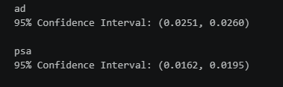
Effect Size
Cohen's h was calculated to measure the practical significance of the difference between the two conversion rates.
Interpretation
- Small effect
- Medium effect
- Large effect


Power Analysis
Statistical power was calculated to determine whether the sample size was sufficient to detect a meaningful difference between the two groups.


Results and Business Insights
Visualizations
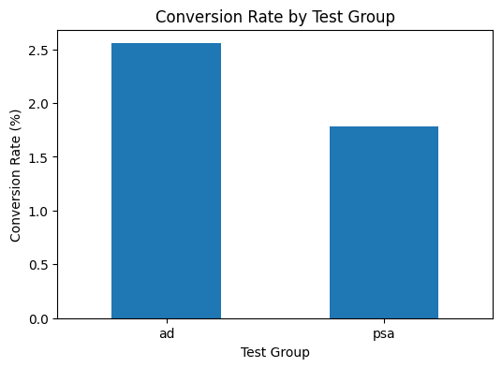

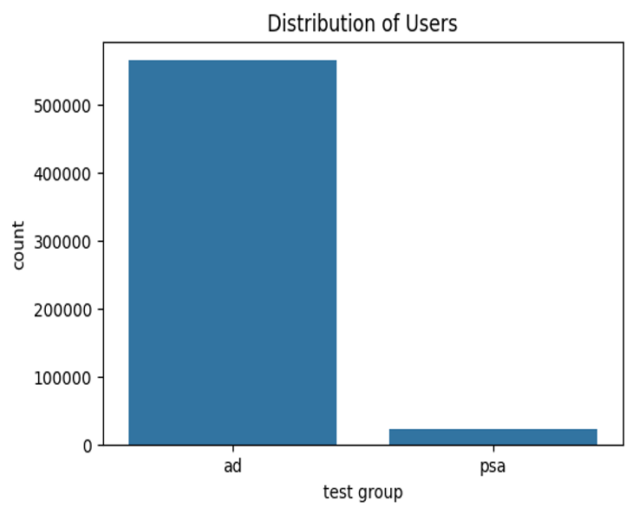
Key Findings
- The conversion rates of both groups were compared using statistical methods.
- Hypothesis testing was conducted using both the Chi-Square Test and the Two-Proportion Z-Test.
- Confidence intervals were calculated to estimate the precision of the conversion rates.
- Effect size was measured to determine the practical importance of the observed difference.
- Power analysis confirmed whether the available sample size was adequate.
Business Recommendation
If your p-value was greater than 0.05:

The statistical analysis indicates that there is no significant difference between the conversion rates of the advertisement group and the PSA group. Therefore, there is insufficient evidence to conclude that the PSA campaign performs better than the existing advertisement. The organization should continue using the current advertising strategy or conduct additional experiments with a larger sample size before making any changes.

If your p-value was less than 0.05:

The analysis shows a statistically significant difference between the two groups. The version with the higher conversion rate should be adopted as it is likely to improve business performance.

Conclusion and Future Scope
Conclusion
This project successfully demonstrated the application of A/B testing using Python. Conversion rates were compared using statistical techniques including the Chi-Square Test and the Two-Proportion Z-Test. Confidence intervals, effect size, and power analysis provided additional evidence for interpreting the results.

The findings support data-driven decision-making and highlight the importance of statistical testing before implementing business changes.

Future Scope
Future improvements may include:
- Conducting experiments with larger and more balanced sample sizes.
- Testing multiple marketing strategies simultaneously.
- Applying Bayesian A/B testing methods.
- Building real-time dashboards using Tableau or Power BI.
- Performing customer-level segmentation before experimentation.
References
- Pandas Documentation
- NumPy Documentation
- SciPy Documentation
- Statsmodels Documentation
- Matplotlib Documentation
- Seaborn Documentation
- Marketing A/B Testing Dataset (Kaggle)

